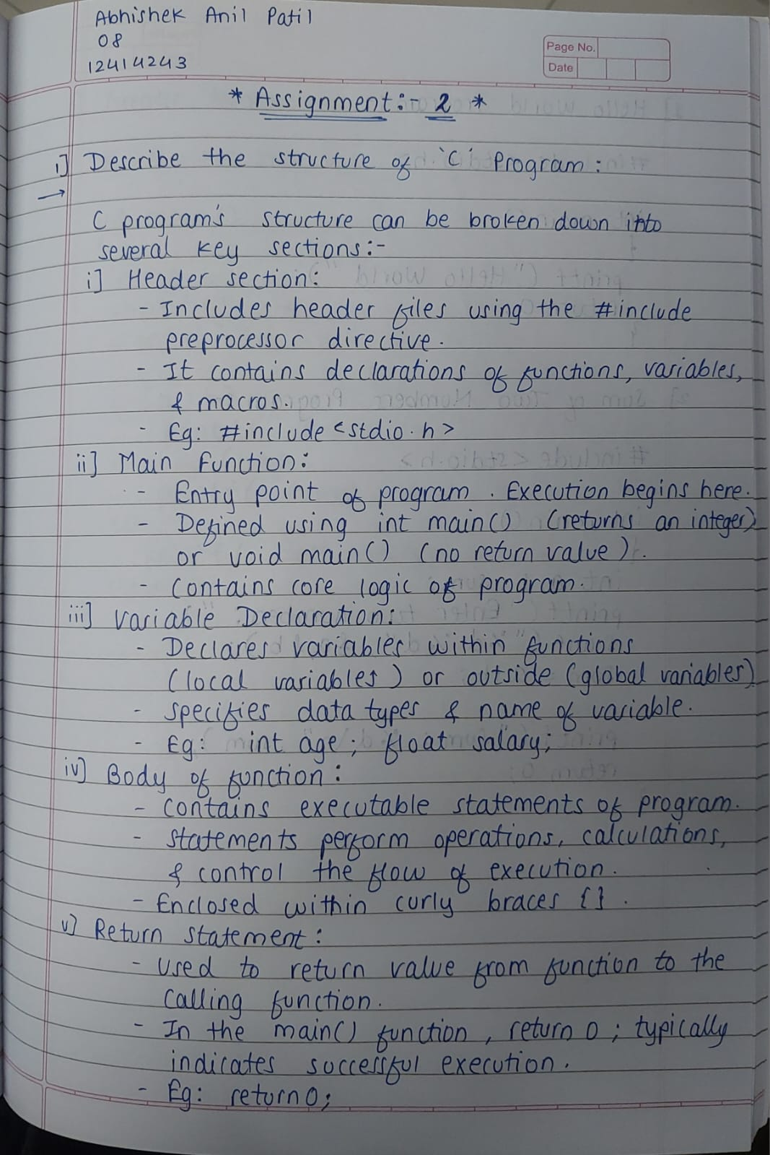
C HEADER FILES & THEIR PURPOSES

Header File | Purpose
stdio.h | Provides functions for standard input and output operations (e.g., printf(), scanf()).
stdlib.h | Provides general utility functions (e.g., memory allocation, process control, conversions).
string.h | Provides functions for manipulating strings (e.g., strcpy(), strlen(), strcmp()).
math.h | Provides mathematical functions (e.g., sqrt(), pow(), sin(), cos()).
conio.h | Provides functions for console-related operations (e.g., clrscr(), getch(), gotoxy()) - Non-standard, compiler-specific.
ctype.h | Provides functions to classify and transform characters (e.g., isalpha(), isdigit(), toupper()).
time.h | Provides functions for working with date and time (e.g., time(), localtime()).
assert.h | Provides the assert() macro for debugging.
errno.h | Provides macros for reporting error conditions.
float.h | Defines limits for floating-point types.
limits.h | Defines limits for integer types.
locale.h | Provides functions for cultural and language-specific settings.
setjmp.h | Provides functions for non-local jumps (e.g., setjmp(), longjmp()).
signal.h | Provides functions for handling signals (e.g., signal(), raise()).
stdarg.h | Provides functions for handling variable-length argument lists.
stddef.h | Defines several commonly used data types (e.g., size_t, ptrdiff_t).
iso646.h | Defines macros for alternative spellings of operators and keywords (e.g., and for &&, or for `
wchar.h | Provides functions for working with wide characters.
wctype.h | Provides functions for classifying wide characters.

